**Assessing the impact of frailty on survival time for patients undergoing dialysis: a comparison of retrospective survival analyses using linked data from two sources**

Samuel D. Relton1, Jenny Hewison1, Zoe Rogers, Usha Appalsawmy2, Kuldeep Sohal3, John Birkinshaw3 John Stoves4, Robert West1 and Andrew Mooney5

**Positions and affiliations:**

Samuel D. Relton, Associate Professor in Health Data Science, Leeds Institute of Health Sciences, School of Medicine, University of Leeds, UK

Jenny Hewison, Professor of the Psychology of Healthcare, Leeds Institute of Health Sciences, School of Medicine, University of Leeds, UK

Zoe Rogers, Research Assistant, Leeds Institute of Cancer and Pathology, School of Medicine, University of Leeds, UK

Usha Appalsawmy, Consultant Renal Physician, Leeds Teaching Hospitals NHS Trust

Kuldeep Sohal, Programme Manager, Connected Bradford, Bradford Institute for Health Research, Bradford, UK

John Birkinshaw, Senior Database Manager, Connected Bradford, Bradford Institute for Health Research, Bradford, UK

John Stoves, Consultant Renal Physician, Bradford Royal Infirmary, Bradford, UK

Robert West, Professor of Biostatistics, Leeds Institute of Health Sciences, School of Medicine, University of Leeds, UK

Andrew Mooney, Consultant Renal Physician, Leeds Teaching Hospitals NHS Trust and Honorary Clinical Associate Professor, School of Medicine, University of Leeds, UK

**Corresponding author:**

Samuel D. Relton, Leeds Institute of Health Sciences, University of Leeds, Clarendon Way, Leeds, LS2 9NL, United Kingdom. Tel. +44 (0)113-34-36731. Email: s.d.relton@leeds.ac.uk

**Word count:** Abstract=295 (max 300); Text=3564

**ABSTRACT**

**Background and hypothesis**

Over the last 30 years, with increasing co-morbidity and frailty among people with end-stage kidney disease there is increasing recognition that dialysis may be of little benefit in some patient groups. We examined the utility of the electronic frailty index (eFI) in modelling the survival time of patients starting dialysis at a single renal unit in the north of England, hypothesising this would give useful prognostic survival information.

**Methods**

Two datasets describing the same population of patients receiving dialysis over a 226-month period (2000-2019) at a single dialysis unit were used (n=599 and 553 participants). One dataset was from a primary care-derived cohort of those receiving dialysis according to their primary care record (linked to UK Renal Registry submissions), and the other was based upon the people submitted by the renal unit to the UK Renal Registry (linked with primary care data to facilitate eFI calculation). Retrospective survival analysis was undertaken with hazard ratios for the impact of eFI and other covariates on survival.

**Results**

Frailty score at the beginning of dialysis treatment has a strong effect on survival time following dialysis initiation using either the primary care-derived or Renal Registry dataset. Nevertheless, differences in survival and the relation between eFI score and survival were demonstrated depending on whether primary care-derived or UK Renal Registry datasets were examined.

**Conclusions**

This represents the first study of eFI utility within tertiary renal care, demonstrating a strong association between frailty measured by eFI and survival time for patients on long-term dialysis. However, significant differences between primary care-derived and UK Renal Registry-derived survival at different frailty scores were demonstrated. These differences indicate a need for greater understanding and analysis of large datasets before they can be used to discuss patient treatment choices, service planning, and delivery.

**Key words:** electronic frailty index, eFI, renal, dialysis, survival modelling

**INTRODUCTION**

Although dialysis has transformed the outlook for patients with end stage kidney disease, over the last 30 years, the population of patients receiving this treatment has changed significantly[1]. In the UK the median age of patients starting dialysis has risen to over 65 and with it rates of comorbidity have also risen[1]. Dialysis is a highly invasive treatment, associated with significantly reduced quality of life,[2] heavy symptom burden[3] and limited survival[1]; increasingly, studies are suggesting there are patient groups for whom this treatment carries little, if any, benefit[4–8].

Thus, there are now published guidelines advocating the consideration of conservative management or non-dialysis treatment for selected patient groups[9]. Such guidelines make it increasingly important to identify those who would derive little (if any) survival benefit from dialysis. Factors which have been shown to impact on survival after commencing dialysis include comorbidity[4–8], functional status[4–8] and frailty[10,11].

Frailty is the state of reduced resistance to adverse stressors. Recent conceptualisations based on a defined phenotype[12] or model of accumulated deficits[13] have allowed measurement and risk stratification in a variety of healthcare settings[14–16].

On this background, the electronic frailty index (eFI) has recently been described[17]. Based on the Rockwood model of cumulative frailty, and comprising 36 items, it is automatically calculated from 2171 primary care Read Codes. Developed and validated in a population of 65-95 year-old community dwelling people, it has been shown to correlate with hospitalisation, institutionalisation and survival over a 5 year period in this group[17]. Following this demonstration of utility, the eFI has been made available to all General Practices in England and Wales; it is also available in some secondary care settings, but had not previously been validated in any tertiary renal practice.

We speculated that the eFI could give valuable prognostic information for people with advanced kidney disease approaching dialysis, which information could be used for commissioning and service planning, as well as shared decision-making with patients related to dialysis treatment and targeting of specific frailty-relevant interventions.

Therefore, we sought to analyse data pertaining to people receiving dialysis at a single large renal unit in the north of England over a fixed time period, seeking correlation between outcomes on dialysis and eFI scores.

Typically such research would use the UK Renal Registry to decide who should be included within the cohort for analysis. The UK Renal Registry (UKRR) was established by the Renal Association (the professional society of nephrologists in the UK) in 1995, and it collates data from renal centres and hospital laboratories to improve the care of patients with kidney disease in the UK; the UKRR's data collection was originally limited to people on a renal replacement therapy, though more recently it has started collecting data on acute kidney injury and advanced chronic kidney disease in secondary care not on dialysis [1]. Recently Hole et al [18] described a number of potential issues with this approach, suggesting that data provenance issues with the UKRR might lead to underestimation of mortality. To investigate this we used two approaches to define our study cohort that, in theory, should lead to the same study population.

The first study population was obtained in the standard fashion: using data submitted to the UKRR by the renal unit in Bradford Teaching Hospitals Trust, which provides dialysis services to all patients in the region. This population receiving dialysis was augmented with the Connected Bradford database (cBradford) to obtain associated primary care data. The Connected Bradford database (cBradford) covers over one million citizens, five NHS Trusts, 86 general practitioners and 200 schools, and links pseudonymised health, education, social care, environmental and local government data.

The second study population was identified using primary care codes within the cBradford database: we selected all patients who were coded in their primary care record to have received dialysis within the period of analysis (list of codes in Supplementary Table 1). These primary care records were augmented with information from the UK Renal Registry (e.g. date of transplant).

As these criteria both describe patients receiving long term dialysis and this renal unit was the single dialysis provider for the entire catchment area of those in the cBradford population, both cohorts should theoretically have been identical; one was primary care-derived with linked UK Renal Registry data, and the other was UK Renal Registry-derived with linked primary care data. However, we found some differences in the populations captured, which emphasises the need for careful consideration of selection biases when working with electronic healthcare records. Both datasets were subject to identical analysis.

**METHODS**

**Study design, setting and patient identification**

We analysed a cohort of patients beginning dialysis in a northern English hospital between 1st May 2000 and 6th March 2019 (the data extract date), using two cohort definitions as outlined above: first by augmenting the UKRR submission with primary care data, and second by identifying dialysis within the primary care record and looking for the associated UKRR data. The cBradford Research Database provided dialysis start dates, kidney transplant dates, basic demographics from the secondary care records linked to the clinical codes from the primary care record for patients used to extract frailty scores and conditions within the Quality Outcomes Framework (QOF). The Connected Bradford Research Database ethical approval supports quality improvement and research purposes – primary care clinical data were recorded using the Read code CTV3 classification system. Data quality checks are performed centrally to assess data integrity, quality and representativeness of the population in England (<http://www.researchone.org/data/>). The UKRR data was taken from the internal database that forms the basis of the unit submission to the registry.

The study was approved by the ResearchOne Project Committee and the University of Leeds, Medicine and Health University Ethics Review Committee (MREC-18-005) and the Connected Bradford Research Ethics Committee (IRAS ref:227117 and REC ref:17/EM/0254). No patients or members of the public were directly involved in this research.

**Study participants**

We identified all patients who began dialysis from the renal unit during the study period using two cohort definitions. First, the Bradford Renal Unit submissions to the UKRR were augmented with primary care data from cBradford which we refer to as the UKRR-based cohort. Second, people were selected from within the cBradford database by searching for CTV3 codes indicating long term dialysis and matched with their UKRR submission data – referred to as the CTV3-based cohort. The CTV3 codes used as inclusion criteria for the second cohort are shown in Supplementary Table 1. All individuals beginning dialysis within the study period with linked primary care records were eligible for inclusion. In order to determine frailty scores before treatment, patients whose primary care record began after the start of dialysis were removed from the dataset before analysis, which left n=599 remaining in the UKRR data and n=553 in the CTV3-based data. The eligibility for study inclusion ended on the earliest of the following: date of death or date of the last data item recorded from their GP practice.

**Study covariates and outcomes**

The variables used for analysis were those collected within the UKRR database which we had access to (to ensure parity between both datasets), and the electronic frailty index of each patient. We do not have access to the full UKRR database, so they were extracted from the primary care record; UKRR co-morbidity data were taken from secondary care records submitted by supervising units for the period of time covered by this study. CTV3 codes for these covariates were taken from QOF and the eFI. The full list of covariates can be seen in Table 3. All covariates are calculated based upon the patient history at the time they started dialysis. The UKRR submission was used to look for the start date of dialysis and the date of transplant/death if applicable.

Mortality was extracted both from the date of death recorded in the primary care record and renal unit database of each patient (they matched in all cases), whilst the date of any kidney transplant was extracted from the renal unit database. Within the survival analysis, patients were right-censored after the earliest date when the following events occurred: death, a kidney transplant being recorded within the renal unit database, or the last CTV3 code entered into their primary care record.

In terms of missing data, the non-appearance of a CTV3 code matching one of the conditions above was taken as an indication that the patient had not suffered from that specific condition. Basic demographics such as age at the start of dialysis and date of death did not have any missing values. The exception to this was for BMI where some patients had no matching events in their primary care record (see Table 1). Since BMI was treated as a categorical variable in our analyses we encoded these cases with a specific ‘Missing’ category.

**Statistical analysis**

Baseline patient characteristics are reported using either percentages or the median and inter-quartile range (IQR) for binary and continuous variables, respectively. We show the summary statistics where patients are split by eFI category (fit, mild, moderate, and severe frailty) as defined in the original analysis[17], and look for any difference between the two cohort definitions using chi-squared tests. There will be some overlap between the two cohorts, as they target the same patient group, so caution is required when interpreting any differences. Unfortunately the two data extracts came with different pseudonyms, so we are unable to determine the exact proportion of overlap.

Regarding statistical modelling, both cohort definitions were analysed in the same way as follows. First, a univariate analysis of all the dependent variables using the Log-Rank test to compare the Kaplan-Meier curves of patients with various comorbidities. The continuous measures (age and eFI score) are categorised for the univariate testing: age is split into quartiles whilst the eFI is split into the standard fit, mild, moderate, and severe frailty categories.

Second, we performed multivariate survival analysis to demonstrate the utility of primary care data and the eFI in dialysis survival modelling using only the information available at the beginning of dialysis treatment. Cox models were used throughout with the continuous variables (age and eFI) were modelled using splines, where the number of knots is determined as explained below. Analyses were undertaken using Python for data cleaning and the R libraries splines, survival, and survminer for statistical modelling.

We compare two survival models per cohort definition.

1. A model using only the variables collected by the UK Renal Registry.

2. A model adding the eFI score to the variables collected by UKRR.

The comparison of these models allows us to see the baseline performance using existing variables and discover the added impact of using the eFI, to investigate the potential of linked primary and secondary care data in this patient group.

Models are compared using the concordance index, D-statistic and the Akaike Information Criterion (AIC). The number of knots used to model the effect of age and the eFI score are selected to minimise the AIC, in both cases this resulted in a linear term. Hazard ratios (HRs) and 95% confidence intervals (CIs) are reported. Model assumptions are checked by testing the Schoenfeld, Martingale, and deviance residuals.

**RESULTS**

**Overall mortality and patient characteristics**

After data extraction and removing those whose available linked primary care record began after the start of dialysis treatment, there were n=599 patients remaining in the UKRR-based cohort and n=553 in the CTV3-based cohort. Overall 46.1% of patients died over the study period within the UKRR-based cohort, and 53.7% within the CTV3-based cohort. The median age at the start of dialysis was 60 years (IQR=[40, 75] years) in UKRR and 60 (IQR=[37, 76]) in CTV3. The proportion of patients who were male was 60.5% using UKRR data vs 58.2% using CTV3 data and the median survival time was 5.14 years (95% CI=[4.27, 6.18] years) in UKRR and 5.6 (95% CI=[4.8, 6.7]) in CTV3. The median frailty score at the start of dialysis was 0.19 (IQR=[0.11, 0.31]) in UKRR and 0.19 (IQR=[0.08, 0.31]) in CTV3, equivalent to just under 7 of the 36 deficits.

A summary of the prevalence of our collected variables amongst all patients is shown in Table 1. This shows a number of differences between the two cohorts, for example and most notably in rates of ischaemic heart disease. Theoretically these two groups should be the same, but there are clearly different people within each cohort. It is unclear why these differences occur, though ischaemic heart disease is a common complication of CKD so there may be better screening and recording for those who are on the renal registry.

In Figure 1a and 1b, we show Kaplan-Meier curves for both cohort definitions. Figures 2a and 2b show Kaplan-Meier curves split by frailty category within each cohort definition, with the median survival of each group listed in Table 2. Of particular note is the large difference between median survival estimates in the severely frail group of 1.6 vs 2.7 years, and that longer-term survival appears to be better in the cohort derived from the UKRR.

**Univariate Analysis**

The Log-Rank test results can be found in Table 3 for each cohort definition. We see that most of the recorded covariates are predictive, and that the strength of association is generally similar between the two cohorts despite the differences noted above.

**Multivariate Analysis**

In Table 4 we show the hazard ratios for fitting a survival model in each cohort without including the eFI. We see that hazard ratios are comparable between cohorts with the only major difference being in ischaemic neuropathic ulcers (CTV3 HR=7.1, UKRR HR=2.9); in the CTV3 cohort there were very few patients with this condition leading to higher variability in the effect size and confidence interval. The model metrics showed better concordance with the CTV3 cohort, but lower AIC with the UKRR cohort.  
CTV3 Concordance = 0.739, AIC=3129.8, D=1.593

UKRR Concordance = 0.690, AIC=3068.3, D=1.258

In Table 5 we add the eFI score as an additional predictor. As previously, we see that the models are largely comparable, though the eFI is a hugely important predictor in both. Within the CTV3 cohort the hazard ratio is unfeasibly high (HR=34.4 95% CI=[8.7, 136.3]), which we hypothesise to be related to performance bias: patients which are known to be highly frail receive closer attention resulting in more thorough coding of their healthcare conditions and a more accurate frailty score. Similarly to the models without the additional eFI, the CTV3 cohort had superior concordance, with the UKRR cohort having lower AIC.

CTV3 Concordance=0.755, AIC=3107.5, D=1.727

UKRR Concordance = 0.691, AIC=3067.4, D=1.291

**DISCUSSION**

This study is the first validation of the electronic Frailty Index for its predictive utility in tertiary renal care. It also provides the first analysis of dialysis survival based on frailty scoring which has been generated from routinely collected primary care data. Finally, it provides the first analysis of dialysis survival among a cohort of people identified from their primary care record.

In keeping with other studies, frailty measured among dialysis patients by the eFI in the cBradford dataset is more prevalent, more severe and occurring at an earlier age in this cohort than similar groups who are not receiving dialysis[19–21]. The differences are particularly striking compared to the community dwelling (primary care-based) population in which the eFI was developed[17]; the median survival among this dialysis cohort is less than half of that in the eFI development cohort at all levels of frailty; furthermore, this reduced survival is seen in a group of patients both with a median age that is 15 years younger and a mean eFI score which is significantly higher. These findings are in keeping with other studies which describe the impact of frailty on outcomes in people living with CKD and/or receiving dialysis[10,11,20–23].

In addition to defining the frailty prevalent among patients receiving dialysis, our analysis also studied the effect that frailty measured in this way has on outcomes in such patients. However, comparative analysis of the outcomes using the two datasets under investigation revealed differences even though the data collection design meant that both approaches should have identified the same population cohort. Thus we could identify that, although there was considerable overlap, there were different people included/excluded within the populations in each set. This can be recognised by discrepancies in demographic data, but also by comparison of some of the parameters within the datasets – for example, there were more patients in the cBradford dataset in the lowest frailty quartile (i.e., more “fit” patients; 58% vs 42%) compared to the UK Renal Registry dataset and there were other discrepancies such as prevalence of smokers between the two groups. It would appear, therefore, that despite there being considerable overlap, these were not identical populations. This phenomenon of there being discrepancies between cohorts of patients identified to be receiving dialysis has also been found by others, depending on whether the dataset was derived from primary care, secondary care or from UKRR submissions[24].

Nevertheless, the survival curves for patients within the fit, mild, moderate and severely frail quartiles (as described in the original eFI development paper), demonstrated that the eFI was a strong indicator of likely survival whether using the cBradford or UK Renal Registry dataset. We believe that survival according to eFI score could be highly valuable in pre-dialysis counselling, indicating the likely cohort patients belong to and the expected survival benefit following dialysis initiation, even though patients living with frailty value functional outcomes rather than just length of survival[25–27]. There is, furthermore, merit in using an objective score to quantify severity of frailty, as physician perceptions of frailty often underestimate the degree of frailty which is present[28].

For these advantages to be realised in clinical practice or service planning, however, the discrepancies between the outcomes viewed from primary or secondary care-derived datasets need to be properly understood. In the cBradford dataset, between the least and most frail eFI groups, the survival curves separate early in the course after dialysis initiation, but continue to widen so that ultimately the least frail quartile have a median survival approximately 3-fold superior or 10 years longer compared to that of the most frail. Those in the “fit” category appear to have more than 50% chance of surviving 10+ years whereas those who are moderately or severely frail appear unlikely to survive longer than three years.

However, whereas the “fit”, “mild” and “moderate” frailty groups UK Renal Registry dataset have largely similar survival curves to the cBradford dataset, outcomes in the “severe” frailty group are most different, with even the most frail appearing to have a median survival of approximately 3 years – approximately twice that of the cBradford cohort. These results bear comparison with a recent analysis of survival undertaken as part of NHS Specialised Services[29]. In this report, the effect of the Hospital Frailty Risk Score (HFRS) (a secondary-care measure of frailty based on ICD-10 codes[30]) among patients aged over 75 found no patients free from frailty among the dialysis cohort studied (the dialysis cohort was defined by secondary-care based specialty codes). A similar divergence of survival as that seen in our UK Renal Registry analysis was demonstrated between groups with a 30-month survival of nearly 60% among the most severely frail group[29]. In our study, all ages at dialysis start were included, and considerable care was taken to record deaths from both primary and secondary care data (in both datasets that we analysed), whereas deaths outside hospital were not detected in the HFRS analysis and may have underestimated overall mortality rates.

The “pseudonymisation” of the datasets prior to analysis precludes a complete examination of the reasons for these differences between outcomes in the cBradford and UK Renal Registry datasets in the current study, but knowledge of the datasets’ provenance enables some limited exploration. The presence of greater numbers of dialysis patients in the cBradford dataset who do not have a “CKD” code raises the possibility that patients with AKI may have been incorrectly coded and included in the analysis (although there were also significant but fewer numbers with this anomaly in the UK Renal Registry cohort). Furthermore, the problem of accurately identifying early mortality among patients starting dialysis from end stage kidney disease has been recognised and described by Hole et al[18], and all submissions to the UK Renal Registry do contain at least some curated data which might lead to underestimations of these very early deaths in chronic dialysis patients. In addition, there were some items in the primary care record (e.g. BMI) which were incompletely recorded, and it is possible that some other data were missing, and it is further possible that this impacted on eFI scores.

There are other potential limitations to the study presented. Significantly, the group under study all commenced dialysis, and so this study gives no comparative outcome data for those who chose not to receive this treatment. Further studies including comparisons between patients choosing dialysis or conservative management of their advanced kidney disease would be helpful, particularly, for example, examining eFI scores in the pre-dialysis decision-making period. The data also give indications of likely survival at population level, which may be more difficult to utilise in individual patient management[31].

Nevertheless, we believe these results demonstrate that routinely collected patient primary care data such as those which contribute to calculation of the eFI have the potential to improve prognostication, clinical shared decision-making and service planning and are of sufficient interest to merit further investigation and analysis in patients with advanced CKD.

ACKNOWLEDGEMENTS

Connected Bradford is a civic data cooperative that has been made possible by the support from the people and professionals living and working in Bradford. We thank them for their enduring commitment. We also thank Professor Andrew Clegg for advice and support on establishing and developing the project.

FUNDING

This research was funded by the Harry Summers Endowment Fund.

AUTHOR CONTRIBUTIONS

Analysis: SR and ZR had full access to the data in the study and undertook all analysis.

Ethics approval and data acquisition: SR, RW, AM, UA, KS, JB, JS, AC.

Study design: SR, RW, JH, AM.

Creation and validation of diagnostic codes used to define conditions: SR, KS, JB, JS, AC .

Creation of cohort and covariates: SR, KS, JB, JS.

All authors approved the submission.

DATA SHARING

Further details about how to apply for Connected Bradford data are available at

https://www.bradfordresearch.nhs.uk/our-research-teams/connected-bradford/

COMPETING INTERESTS

All authors have completed the ICMJE uniform disclosure form at www.icmje.org/coi_disclosure.pdf and declare: no support from any organisation for the submitted work except for the Harry Summers Endowment Fund.

**Table 1. Patient characteristics at start of dialysis treatment for the UKRR cohort (n=599) and the CTV3 cohort (n=553), presented as mean for continuous variables and percentage for categorical variables. Difference between the two datasets are expressed using p-values calculated via the Chi-squared or t-tests as appropriate.**

|  |  |  |  |
| --- | --- | --- | --- |
|  | **CTV3 cohort** | **UKRR cohort** | **p-value** |
| **Age** | 57.7 | 59.4 | 0.09 |
| **Sex – Female** | 41.8% | 39.4% | 0.41 |
| **Sex - Male** | 58.2% | 60.6% | 0.69 |
| **BMI – Morbidly Obese** | 4.3% | 3.2% | 0.97 |
| **BMI – Obese** | 23.5% | 20.5% | 0.22 |
| **BMI – Overweight** | 28.8% | 28.5% | 0.91 |
| **BMI – Healthy** | 27.5% | 34.2% | 0.01 |
| **BMI – Underweight** | 4.7% | 4.0% | 0.56 |
| **BMI – Missing** | 11.2% | 34.2% | < 0.001 |
| **Smoking – Current** | 18.6% | 27.7% | < 0.001 |
| **Smoking – Ex** | 27.7% | 5.3% | < 0.001 |
| **Smoking - Never** | 53.7% | 66.9% | < 0.001 |
| **Angina** | 10.7% | 13.4% | 0.16 |
| **Cancer** | 10.5% | 9.2% | 0.13 |
| **Chronic Vascular Disease** | 17.7% | 21.4% | 0.11 |
| **Chronic Obstructive Pulmonary Disease** | 8.1% | 6.5% | 0.30 |
| **Diabetes** | 44.1% | 46.6% | 0.39 |
| **Ischaemic Heart Disease** | 17.7% | 26.4% | < 0.001 |
| **Ischaemic Neuropathic Ulcer** | 0.5% | 0.8% | 0.53 |
| **Myocardial Infarction** | 4.3% | 6.7% | 0.08 |
| **Electronic Frailty Index** | 0.21 | 0.21 | 1.00 |

**Table 2. Survival times and 95% confidence intervals for each cohort definition when the population is stratified by frailty category. The Kaplan-Meier curves are shown in Figure 2a and 2b.**

|  |  |  |  |
| --- | --- | --- | --- |
| **CTV3-based Cohort** | **N** | **Deaths** | **Median Survival (Years)** |
| **Fit** | 156 | 57 | 13.3 (12.3 – NA) |
| **Mild** | 189 | 95 | 6.0 (4.4 – 8.2) |
| **Moderate** | 159 | 106 | 3.1 (2.7 – 4.3) |
| **Severe** | 49 | 39 | 1.6 (0.9 - 2.8) |
| **UKRR-based Cohort** | **N** | **Deaths** | **Median Survival (Years)** |
| **Fit** | 125 | 35 | NA (8.5 – NA) |
| **Mild** | 248 | 92 | 7.4 (6.1 – NA) |
| **Moderate** | 173 | 110 | 3.3 (2.7 – 4.1) |
| **Severe** | 30 | 21 | 2.7 (1.8 – NA) |
|  |  |  |  |

**Table 3. Univariate survival analyses p-values using log-rank test, Kaplan-Meier curves for stratification by frailty category are shown in Figure 2.**

|  |  |  |
| --- | --- | --- |
|  | **CTV3 cohort** | **UKRR cohort** |
| **Age (Quartiles)** | < 0.001 | < 0.001 |
| **Sex** | 0.1 | 0.08 |
| **BMI** | < 0.001 | < 0.001 |
| **Smoking** | < 0.001 | 0.05 |
| **Angina** | 0.005 | 0.03 |
| **Cancer** | < 0.001 | < 0.001 |
| **Chronic Vascular Disease** | < 0.001 | < 0.001 |
| **Chronic Obstructive Pulmonary Disease** | < 0.001 | < 0.001 |
| **Diabetes** | < 0.001 | < 0.001 |
| **Ischaemic Heart Disease** | 0.004 | < 0.001 |
| **Ischaemic Neuropathic Ulcer** | < 0.001 | 0.004 |
| **Myocardial Infarction** | 0.003 | 0.05 |
| **Electronic Frailty Index (Quartiles)** | < 0.001 | < 0.001 |

**Table 4. Hazard ratios for the survival model variables collected by the UKRR with 95% confidence intervals across both datasets.**

|  |  |  |
| --- | --- | --- |
|  | **CTV3 cohort** | **UKRR cohort** |
| **Age** | 1.05 (1.04-1.06) | 1.04 (1.03-1.05) |
| **Sex - Male** | 0.88 (0.67-1.15) | 1.05 (0.81-1.36) |
| **BMI – Morbidly Obese** | 0.98 (0.53-1.81) | 0.86 (0.43-1.72) |
| **BMI – Obese** | 0.86 (0.60-1.22) | 1.03 (0.74-1.42) |
| **BMI – Overweight** | 0.83 (0.60-1.15) | 0.79 (0.78-1.08) |
| **BMI – Underweight** | 1.38 (0.58-3.26) | 0.27 (0.09-0.87) |
| **BMI – Missing** | 1.58 (1.10-2.26) | 1.50 (0.90-2.51) |
| **Smoking – Current** | 2.20 (1.58-3.06) | 1.21 (0.91-1.60) |
| **Smoking – Ex** | 1.16 (1.20-2.22) | 1.40 (0.88-2.22) |
| **Angina** | 0.54 (0.32-0.88) | 0.67 (0.44-2.56) |
| **Cancer** | 1.37 (0.97-1.93) | 1.35 (0.92-1.97) |
| **Chronic Vascular Disease** | 1.76 (1.09-2.83) | 1.17 (0.76-1.79) |
| **Chronic Obstructive Pulmonary Disease** | 1.09 (0.73-1.63) | 1.34 (0.88-2.04) |
| **Diabetes** | 2.05 (1.56-2.68) | 1.92 (1.44-2.56) |
| **Ischaemic Heart Disease** | 0.95 (0.66-1.37) | 1.09 (0.81-1.46) |
| **Ischaemic Neuropathic Ulcer** | 7.11 (2.13-23.71) | 2.94 (1.04-8.31) |
| **Myocardial Infarction** | 1.15 (0.66-2.00) | 1.13 (0.70-1.83) |

**Table 5. Hazard ratios for the survival model using the eFI and UKRR variables with 95% confidence intervals across both datasets.**

|  |  |  |
| --- | --- | --- |
|  | **CTV3 cohort** | **UKRR cohort** |
| **Age** | 1.04 (1.03-1.05) | 1.04 (1.03-1.05) |
| **Sex - Male** | 1.00 (0.76-1.31) | 1.10 (0.84-1.43) |
| **BMI – Morbidly Obese** | 0.84 (0.45-1.55) | 0.82 (0.41-1.65) |
| **BMI – Obese** | 0.81 (0.57-1.15) | 1.00 (0.71-1.38) |
| **BMI – Overweight** | 0.83 (0.60-1.16) | 0.78 (0.57-1.06) |
| **BMI – Underweight** | 1.27 (0.54-3.00) | 0.27 (0.08-0.86) |
| **BMI – Missing** | 1.57 (1.10-2.26) | 1.54 (0.92-2.58) |
| **Smoking – Current** | 2.19 (1.57-3.06) | 1.21 (0.91-1.61) |
| **Smoking – Ex** | 1.54 (1.14-2.08) | 1.39 (0.88-2.22) |
| **Angina** | 0.48 (0.29-0.79) | 0.67 (0.43-1.03) |
| **Cancer** | 1.39 (0.99-1.96) | 1.33 (0.91-1.94) |
| **Chronic Vascular Disease** | 1.41 (0.87-2.28) | 1.09 (0.71-1.68) |
| **Chronic Obstructive Pulmonary Disease** | 0.87 (0.87-1.32) | 1.29 (0.85-1.96) |
| **Diabetes** | 1.50 (1.12-2.01) | 1.75 (1.29-2.38) |
| **Ischaemic Heart Disease** | 0.95 (0.66-1.37) | 1.08 (0.80-1.45) |
| **Ischaemic Neuropathic Ulcer** | 5.78 (1.72-19.43) | 2.89 (1.02-2.18) |
| **Myocardial Infarction** | 1.07 (0.62-1.85) | 1.08 (0.67-1.76) |
| **Electronic Frailty Index** | 34.37 (8.67-136.25) | 4.31 (0.81-22.81) |

**Figure 1a. Kaplan-Meier curve showing the survival function for all patients in the primary-care derived cohort and its 95% confidence interval (median survival 5.55 years; 95% CI=[4.8, 6.7] years).**

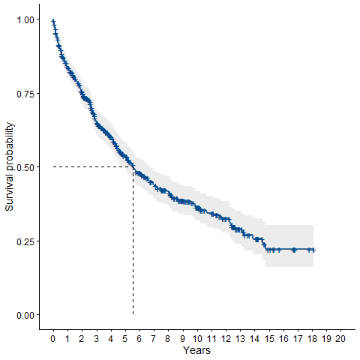

**Figure 1b. Kaplan-Meier curve showing the survival function for all patients in the UKRR-derived cohort and its 95% confidence interval (median survival 5.14 years; 95% CI=[4.1, 6.4] years).**

**Figure 2a. Kaplan-Meier curve showing the survival function stratified by eFI category within the primary care-derived cohort.**

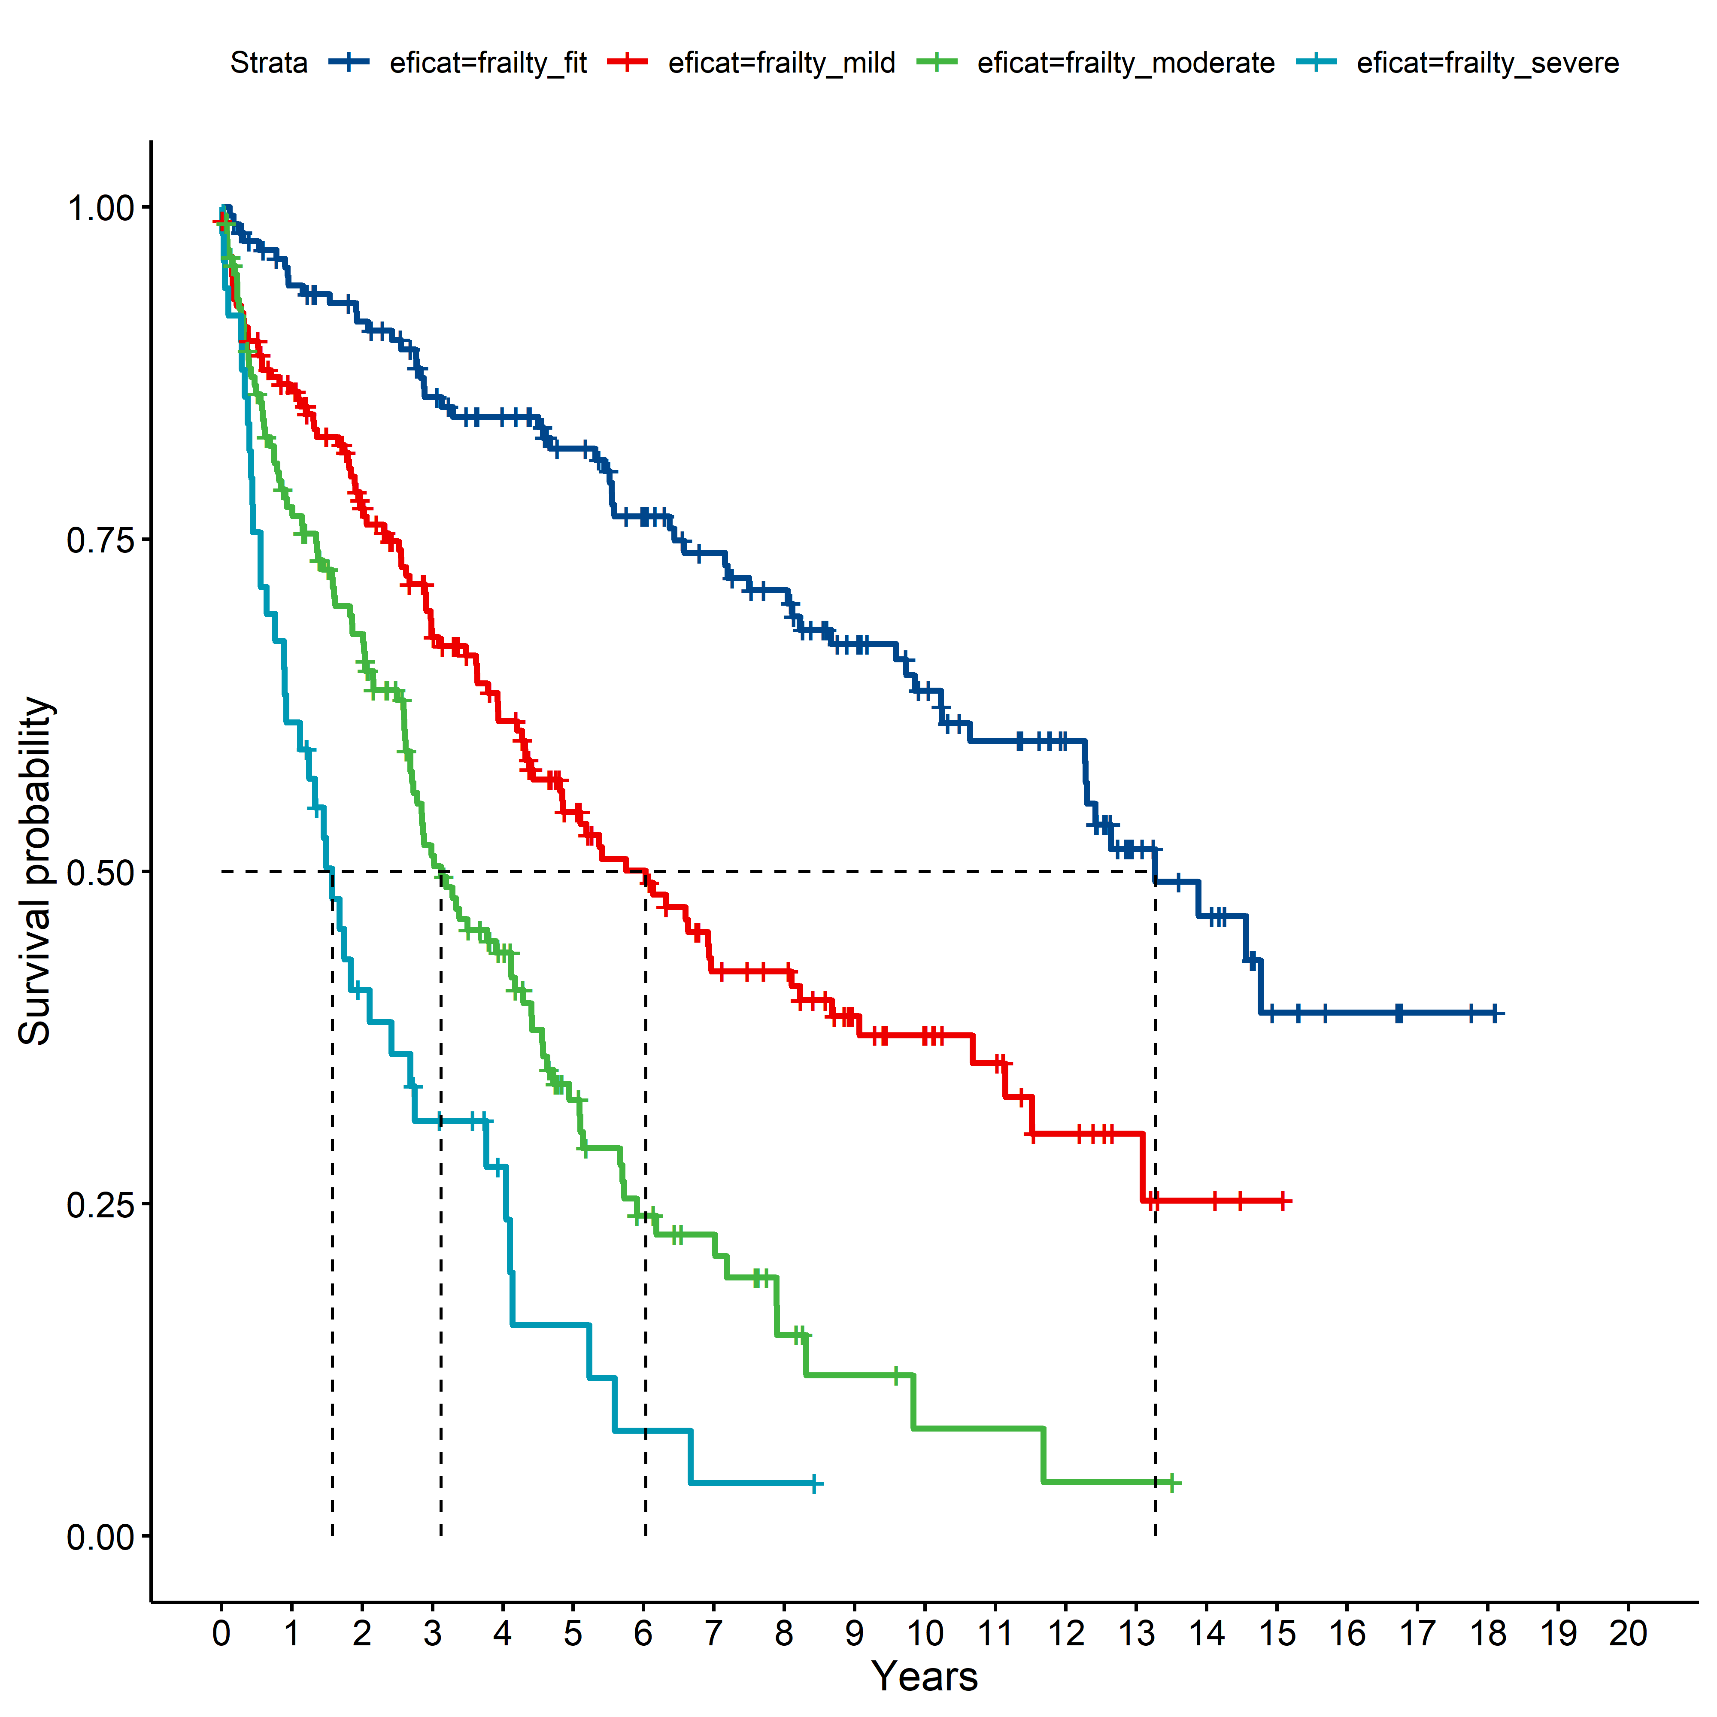

**Figure 2b. Kaplan-Meier curve showing the survival function stratified by eFI category within the UK Renal Registry-derived cohort.**

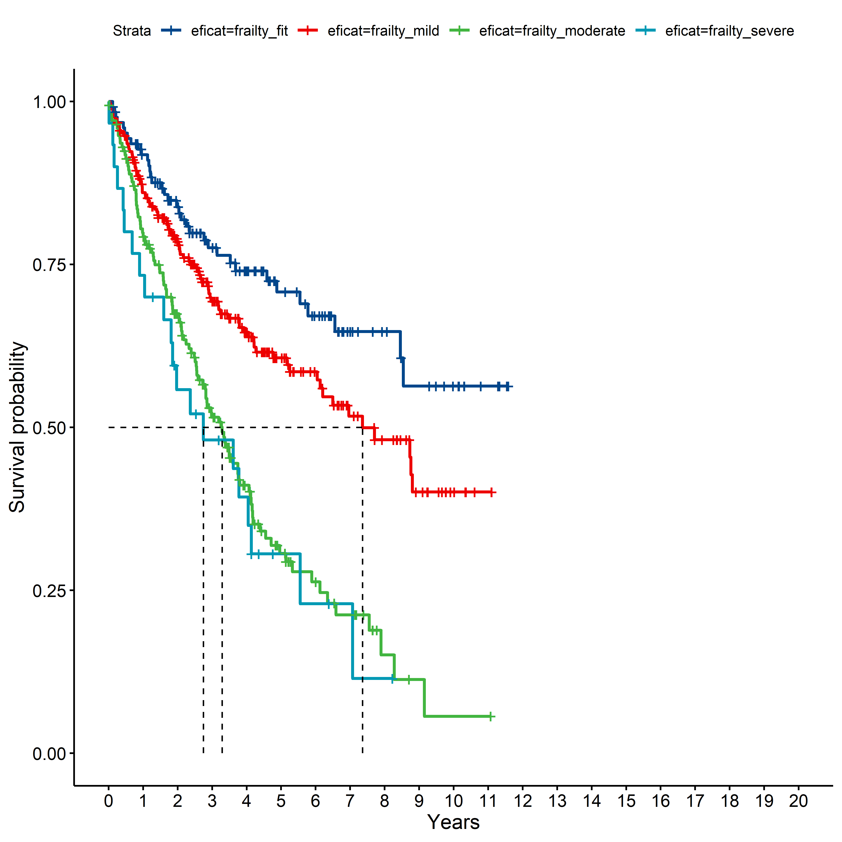

REFERENCES

1 Pyart R, Evans KM, Steenkamp R, *et al.* The 21st UK Renal Registry Annual Report: A Summary of Analyses of Adult Data in 2017. *Nephron*. 2020;144. doi: 10.1159/000504851

2 Nagaraja P, Lodhi V, Garrell D, *et al.* SP682A COST AND OUTCOMES ANALYSIS OF RENAL REPLACEMENT THERAPIES USING REAL-WORLD QUALITY OF LIFE DATA. *Nephrology Dialysis Transplantation*. 2015;30. doi: 10.1093/ndt/gfv200.01

3 Murtagh FEM, Addington-Hall J, Higginson IJ. The Prevalence of Symptoms in End-Stage Renal Disease: A Systematic Review. *Adv Chronic Kidney Dis*. 2007;14. doi: 10.1053/j.ackd.2006.10.001

4 Verberne WR, Tom Geers ABM, Jellema WT, *et al.* Comparative survival among older adults with advanced kidney disease managed conservatively versus with dialysis. *Clinical Journal of the American Society of Nephrology*. 2016;11. doi: 10.2215/CJN.07510715

5 Chandna SM, Schulz J, Lawrence C, *et al.* Is there a rationale for rationing chronic dialysis? A hospital based cohort study of factors affecting survival and morbidity. *BMJ*. 1999;318. doi: 10.1136/bmj.318.7178.217

6 Murtagh FEM, Marsh JE, Donohoe P, *et al.* Dialysis or not? A comparative survival study of patients over 75 years with chronic kidney disease stage 5. *Nephrology Dialysis Transplantation*. 2007;22. doi: 10.1093/ndt/gfm153

7 Tam-Tham H, Quinn RR, Weaver RG, *et al.* Survival among older adults with kidney failure is better in the first three years with chronic dialysis treatment than not. *Kidney Int*. 2018;94. doi: 10.1016/j.kint.2018.03.007

8 Hussain JA, Mooney A, Russon L. Comparison of survival analysis and palliative care involvement in patients aged over 70 years choosing conservative management or renal replacement therapy in advanced chronic kidney disease. *Palliat Med*. 2013;27. doi: 10.1177/0269216313484380

9 Farrington K, Covic A, Nistor I, *et al.* Clinical Practice Guideline on management of older patients with chronic kidney disease stage 3b or higher (EGFR<45 mL/min/1.73 m2): A summary document from the European Renal Best Practice Group. Nephrology Dialysis Transplantation. 2017;32.

10 McAdams-Demarco MA, Suresh S, Law A, *et al.* Frailty and falls among adult patients undergoing chronic hemodialysis: A prospective cohort study. *BMC Nephrol*. 2013;14. doi: 10.1186/1471-2369-14-224

11 Kallenberg MH, Kleinveld HA, Dekker FW, *et al.* Functional and cognitive impairment, frailty, and adverse health outcomes in older patients reaching ESRD-a systematic review. *Clinical Journal of the American Society of Nephrology*. 2016;11. doi: 10.2215/CJN.13611215

12 Fried LP, Tangen CM, Walston J, *et al.* Frailty in older adults: Evidence for a phenotype. *Journals of Gerontology - Series A Biological Sciences and Medical Sciences*. 2001;56. doi: 10.1093/gerona/56.3.m146

13 Song X, Mitnitski A, Rockwood K. Prevalence and 10-Year outcomes of frailty in older adults in relation to deficit accumulation. *J Am Geriatr Soc*. 2010;58. doi: 10.1111/j.1532-5415.2010.02764.x

14 Hewitt J, Carter B, Vilches-Moraga A, *et al.* The effect of frailty on survival in patients with COVID-19 (COPE): a multicentre, European, observational cohort study. *Lancet Public Health*. 2020;5. doi: 10.1016/S2468-2667(20)30146-8

15 Chen CL, Chen CM, Wang CY, *et al.* Frailty is Associated with an Increased Risk of Major Adverse Outcomes in Elderly Patients Following Surgical Treatment of Hip Fracture. *Sci Rep*. 2019;9. doi: 10.1038/s41598-019-55459-2

16 McAlister FA, Lin M, Bakal JA. Prevalence and postdischarge outcomes associated with frailty in medical inpatients: Impact of different frailty definitions. *J Hosp Med*. 2019;14. doi: 10.12788/jhm.3174

17 Clegg A, Bates C, Young J, *et al.* Development and validation of an electronic frailty index using routine primary care electronic health record data. *Age Ageing*. 2016;45. doi: 10.1093/ageing/afw039

18 Hole BD, Casula A, Caskey FJ. Quality assuring early dialysis care: evaluating rates of death and recovery within 90 days of first dialysis using the UK Renal Registry. *Clin Kidney J*. 2022;15. doi: 10.1093/ckj/sfab238

19 Collard RM, Boter H, Schoevers RA, *et al.* Prevalence of frailty in community-dwelling older persons: A systematic review. J Am Geriatr Soc. 2012;60.

20 Johansen KL, Chertow GM, Jin C, *et al.* Significance of frailty among dialysis patients. *Journal of the American Society of Nephrology*. 2007;18. doi: 10.1681/ASN.2007020221

21 Bao Y, Dalrymple L, Chertow GM, *et al.* Frailty, dialysis initiation, and mortality in end-stage renal disease. *Arch Intern Med*. 2012;172. doi: 10.1001/archinternmed.2012.3020

22 Shen Z, Ruan Q, Yu Z, *et al.* Chronic kidney disease-related physical frailty and cognitive impairment: a systemic review. Geriatr Gerontol Int. 2017;17.

23 Walker SR, Gill K, Macdonald K, *et al.* Association of frailty and physical function in patients with non-dialysis CKD: A systematic review. BMC Nephrol. 2013;14.

24 Santhakumaran S, Fisher L, Bang Z, *et al.* Identification of patients undergoing chronic kidney replacement therapy in primary and secondary care data: validation study based on OpenSAFELY and UK Renal Registry. *BMJ Medicine*. 2024;3.

25 Ramer SJ, McCall NN, Robinson-Cohen C, *et al.* Health outcome priorities of older adults with advanced CKD and concordance with their nephrology providers’ perceptions. *Journal of the American Society of Nephrology*. 2018;29. doi: 10.1681/ASN.2018060657

26 Urquhart-Secord R, Craig JC, Hemmelgarn B, *et al.* Patient and Caregiver Priorities for Outcomes in Hemodialysis: An International Nominal Group Technique Study. *American Journal of Kidney Diseases*. 2016;68. doi: 10.1053/j.ajkd.2016.02.037

27 Akishita M, Ishii S, Kojima T, *et al.* Priorities of Health Care Outcomes for the Elderly. *J Am Med Dir Assoc*. 2013;14. doi: 10.1016/j.jamda.2013.01.009

28 Salter ML, Gupta N, Massie AB, *et al.* Perceived frailty and measured frailty among adults undergoing hemodialysis: A cross-sectional analysis. *BMC Geriatr*. 2015;15. doi: 10.1186/s12877-015-0051-y

29 Imam T, Konstant-Hambling R, Fluck R, *et al.* The Hospital Frailty Risk Score - Outcomes in specialised services. *Age Ageing*. 2021;50. doi: 10.1093/ageing/afaa156

30 Gilbert T, Neuburger J, Kraindler J, *et al.* Development and validation of a Hospital Frailty Risk Score focusing on older people in acute care settings using electronic hospital records: an observational study. *The Lancet*. 2018;391. doi: 10.1016/S0140-6736(18)30668-8

31 Arah OA. On the relationship between individual and population health. *Med Health Care Philos*. 2009;12. doi: 10.1007/s11019-008-9173-8